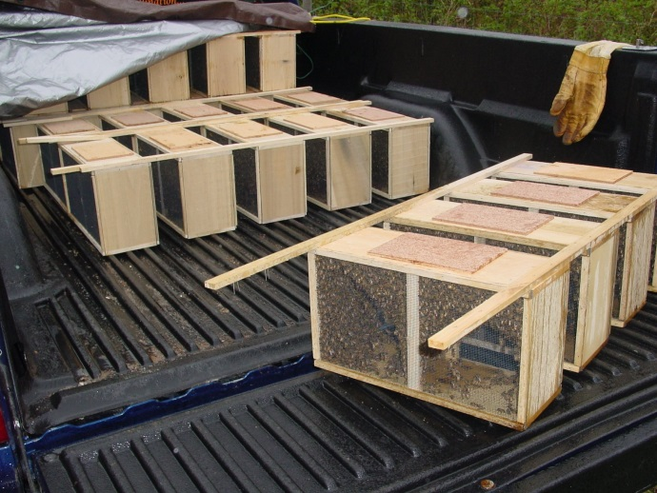

Big T’s Honeybee Farm
Tim & Anna Lindley
1222 Airport Avenue
Greenville, IL. 62246
(618) 780-3772

Orders for Packages
Packages are 3lbs of Italian-Carniolan cross bees and a queen. They are coming from Georgia, and will be available on or around April 4th. Packages are $150.00 each and they must be Pre-Paid by March 15th. To order call 618-780-3772, or email: bigtshoneybeefarm@gmail.com.

