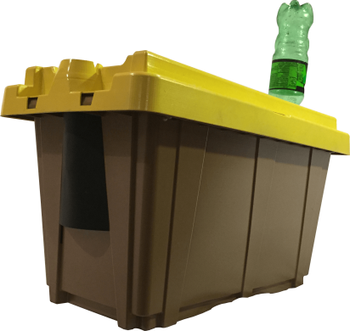
Sign up today for a Nuc from Big T’s Honeybee Farm!

All nucs will come in a plastic pro-nuc, like the one pictured above for $185.00. These nucs will consist of: five frames of brood, honey, pollen, bees with a gentle laying Italian queen. They will be ready to jump-start your new adventure into beekeeping! When the nucs are ready, we will call you. You can come to Big T’s Honeybee Farm, 1222 Airport Ave., Greenville, IL. 62246 and either pick up your nuc and take it home with you, or you can bring your equipment with you, and I will help you transfer the nuc into your equipment, (that way you can see what you are buying). The approximate target date for the nuc availability is later in April or early May, weather permitting. Price: $185.00.
To order: call 618-780-3772, or email bigtshoneybeefarm@gmail.com

