Sugar Bricks – Kloepper Method
Recommended Supplies:
- 8 Lbs. table sugar
- 1.25 cups potable water.
- 2 8 quart stainless steel sauce pot or pan with handles on each side of pan.
- 6 8.5 x 4.5 x 2.5 inch metal homemade bread pans… (Wilton brand from Rural King)
- 1 Extra Large Heavy duty Stirring Spoon
- 1 Box Gallon Ziploc Double Zipper Freezer bags ( 4 Boxes 38@/case from Sam’s Club)
Procedure:
1. I start by setting up two 8 quart stainless steel sauce pans or pots with two handles each on the stove. The mixture is extremely hot when pouring and difficult to handle with a single handle pot, so be careful and use a two handle pot! Set up the six bread pans close to the stove before you start cooking, so you don’t have to carry the hot mixture all over the kitchen and you can pour into molds as soon as the mixture is ready.
2. Pour 1 ¼ cups of water into each saucepan and heat until water is hot, but not boiling.
3. Add 4 lbs. of sugar to each saucepan, stirring constantly until this solution is hot, but not boiling.
4. Very slowly, add the remainder of the sugar or 4 lbs. for a total of 8 lbs. into each pan stirring constantly. If you add too much at a time it will be too stiff to stir and likely to burn. If you find that you have to add additional water do so a tablespoon or so at a time. The resulting sugar brick will leak sugar syrup and have too much moisture in it, if you have to use more than about 1 ½ cups of water total in the 8 lbs. of sugar. Increase the heat until the mixture is boiling for about 2-3 minutes. It will have the consistency of hot applesauce if done correctly and the mixture will be a white or very light tan color. If you have the temperature too hot you will see the mixture start to turn a light brown and you can smell the sugar starting to caramelize. This will make the resulting brick more difficult for the bees to digest and is not recommended. Keep stirring!
5. Once both pans are boiling for 2-3 minutes, grab two potholders and wait for the bubbles to just about stop rising, with only an occasional bubble still making it to the surface. Then pour the mixture quickly into each of the 6 bread pan molds. If you pour when too hot, the rising air bubbles will make the bricks porous where the air bubbles are trapped in the brick. Too cold, and the mixture will solidify making it difficult to pour and the surface of the brick lumpy and uneven.
6. The two sauce pans of sugar will yield about 6 bricks, each about 2 ¼ inches thick and weighing about 2 3/4 lbs. each. Allow bricks to cool until they are still just a little warm to the touch and then invert the metal pans and push slowly and firmly on the bottom and the brick should easily slip out.
7. I tried making bricks using a thermometer and found this method seems to be more reliable. (You may also find that you only need 1 pot and 3 bread pans for molds if you only have a few bricks to make. I make them by the hundreds each year so find the extra pot and bread pans a necessity).
8. I have also found aluminum pots will oxidize and react with minerals in the water and cause the pot to permanently discolor, so use stainless steel.
9. I also recommend a really large strong commercial spoon to stir with. This mixture can get thick and difficult to stir so light weight stirring spoons won’t work well.
10. Obviously, other size pans can be used for molds but I have found this particular pan size will make a sugar brick that fits well inside a gallon Ziploc freezer bag (2 bricks/bag)

Feeding:
- I supplement my hive’s winter stores with 1:1 to 2:1 sugar syrup using a 3” rim top feeder and 1 gallon zip lock freezer bags until the temps cause the bees to stop taking the liquid feed, (usually mid to late October). You normally want to feed 2:1 sugar syrup in the fall, but I find that many times I need to make it closer to 1:1 to prevent the sugar from falling out of solution inside the bags as the temperatures fall.

- I allow the bees to empty the liquid feed bag in the fall and leave it on the top of the cluster over the winter. I find the bees will almost always huddle under the bag. I believe the bag helps traps the heat from the cluster under the plastic. Just make sure the liquid syrup is consumed and the bag is empty. I then place two or three sugar bricks over the plastic bag’s edge, wherever the cluster is located. By keeping a constant supply of feed on each hive starting with liquid syrup and continuing with the sugar bricks, the clusters are almost always feeding and I can very easily supplement with additional sugar bricks as necessary throughout the winter.

- Left Photo below… Hives with 3” rim top feeders in place. Right photo below… Bees feeding on sugar bricks mid-winter.

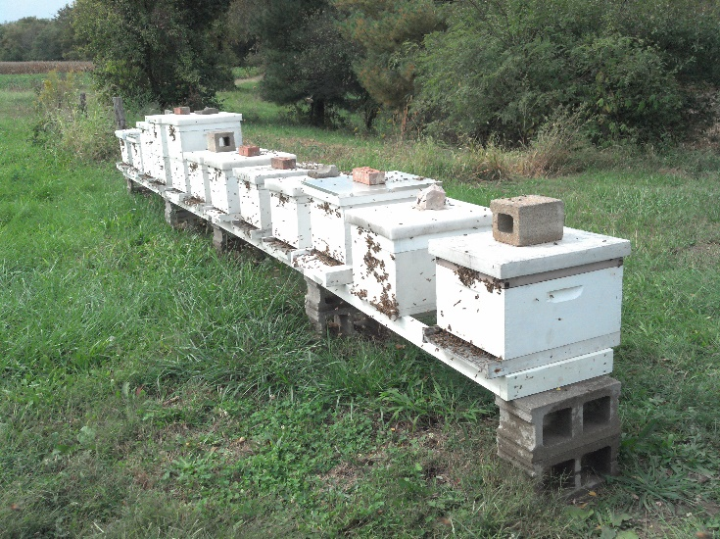 | 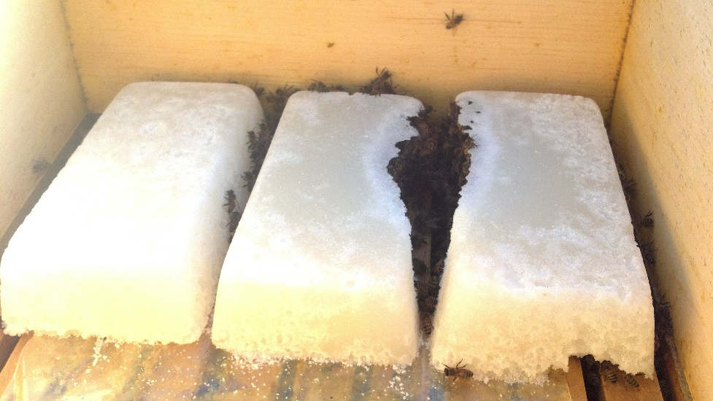

Contact Ken Kloepper - Kloepper Apiaries - Waterloo, IL – kdkloepper@gmail.com for more info.

