Technique for Notching Older Comb
Older, darker, deeper comb is more diﬃcult to notch but s9ll can be used to rear quality queens if 36-­‐hour-­‐or-­‐younger larvae are iden9ﬁed in the cells. The diﬃculty of notching older comb comes from the fact that the cells are lined with cocoons which makes pulling down the bo;om of the cells tougher. To achieve a precise notch in an older comb, the beekeeper can use the sharp edge of the hive tool to drive a cut into the comb at a 90-­‐degree, perpendicular angle and cut the cocoons almost all the way to the bo;om of the cells. Then you can bend them down 1/2", aggressively, and they will rip or tear the rest of the way as shown in the illustra9on below
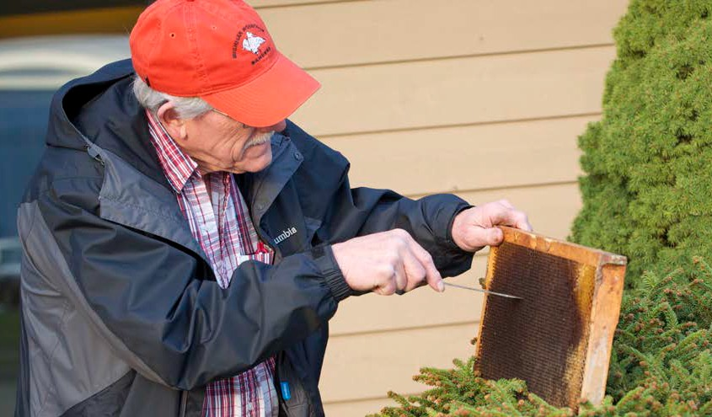
Mel starts to notch an older comb at a 90-­‐degree angle to cut cocoons

- Hive tool at 90-­‐degree angle
- StarHng the notch by cu\ng
- Ripping through cocoons and bending down boWoms of cell walls
- Successful notches, note pulled-­‐ down cocoon Hssues

