Techniques for Notching Virgin Comb
Light-­‐colored, virgin comb is the easiest to notch because the 36-­‐hour-­‐or-­‐younger larvae are easy to see and iden9fy and the comb is easy to notch because there are no cocoons in the cells yet so that the bo;oms of the notched cells bend down readily and cleanly.
Step 1: IdenHfy 36-­‐hour-­‐or-­‐younger larvae
Step 2: Use hive tool to notch out boWom of cells all the way to the founda.on or else bees will repair it back into worker brood

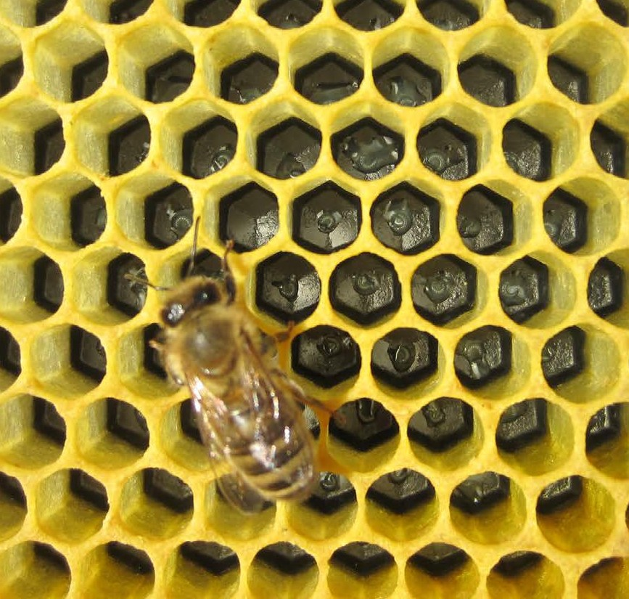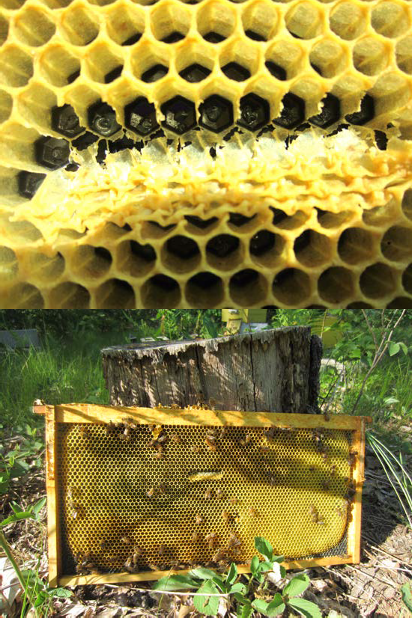 A typical-­‐looking notch on fresh, virgin comb

